Testing for:

Basic user interface functionality:

1. Drop downs
   1. Bus stop drop downs displaying all bus stops
   2. Time selection drop downs
2. Buttons
   1. Calculate button
   2. About button
   3. Help button
   4. Bus change risk buttons
3. Map (Interface)
   1. Bus stops and links all fit in to the map and all are displayed in the correct position
   2. Zoom in and out
   3. Moving across the map
   4. Bus stops highlights when mouse moves over them
   5. Choosing start and end bus stop from the map

Loading data

1. Loading data from a text file
2. Loading data from a database

Algorithm functionality

1. Depart after algorithm
   1. A series of typical, erroneous and extreme cases
2. Arrive before algorithm
   1. A series of typical, erroneous and extreme cases

Feedback mechanism functionality

1. Feedback mechanism (Interface)
   1. Displays correct information
   2. Bus stops in the journey change colour appropriately
   3. Produces a printable document containing more detail
   4. Produces an electronic document containing more detail
   5. Displays an error when the journey is not found

Other features

1. Other
   1. Splash screen

Testing for depart after algorithm functionality

|  |  |  |  |  |
| --- | --- | --- | --- | --- |
| **Test Number** | **Description** | **Variable input data** | **Data type** | **Expected result** |
|  | Testing if the depart after algorithm calculates starting with the link that is straight after the given time  Constant:  Bus Network:  Small network  From: A  To: B  Bus Change Risk: 1 min  Day Category: 1 | Depart after: 05:45 | Typical | Get Bus1A at 06:00 from A and arrive at B at 06:05 |
|  | Depart after:  06:00 | Typical | Get Bus1A at 06:00 from A and arrive at B at 06:05 |
|  | Depart after:  06:01 | Typical | Get Bus1A at 10:00 from A and arrive at B at 10:05 |
|  | Testing if the algorithm calculates the correct journey  Constant:  Bus Network:  Small network  Bus Change Risk: 1 min  Day Category: 1 | From: A  To: F  Depart after:  06:00 | Typical | Get Bus3 at 06:19 and arrive at 06:20 |
|  | From: B  To: F  Depart after:  06:00 | Typical | Preferred:  Get Bus1B from B at 06:11 to A, then take Bus3 from A to F at 06:19 and arrive at 06:20  An alternative result:  Take Bus1A from B to E at 06:05, then at 06:15 get Bus2A to F and arrive at 6:20 |
|  | From: C  To: F  Depart after:  06:00 | Typical | Preferred:  Get Bus1A from C at 06:08 to E, then take Bus2A from E to F at 06:15 and arrive at 06:20  An alternative result:  Take Bus2B from C to A at 06:08, then at 06:19 get Bus3 to F and arrive at 6:20 |
|  |  |  |  |  |
|  |  |  |  |  |
|  |  |  |  |  |
|  |  |  |  |  |

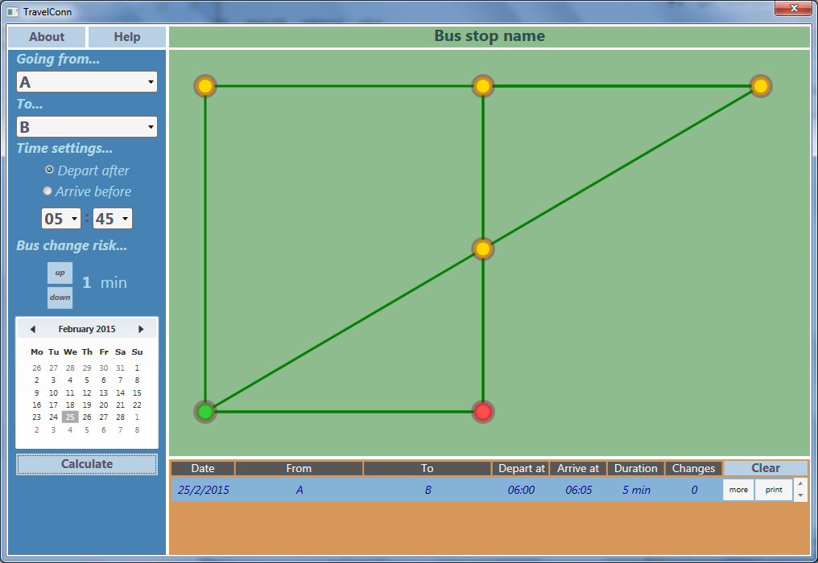

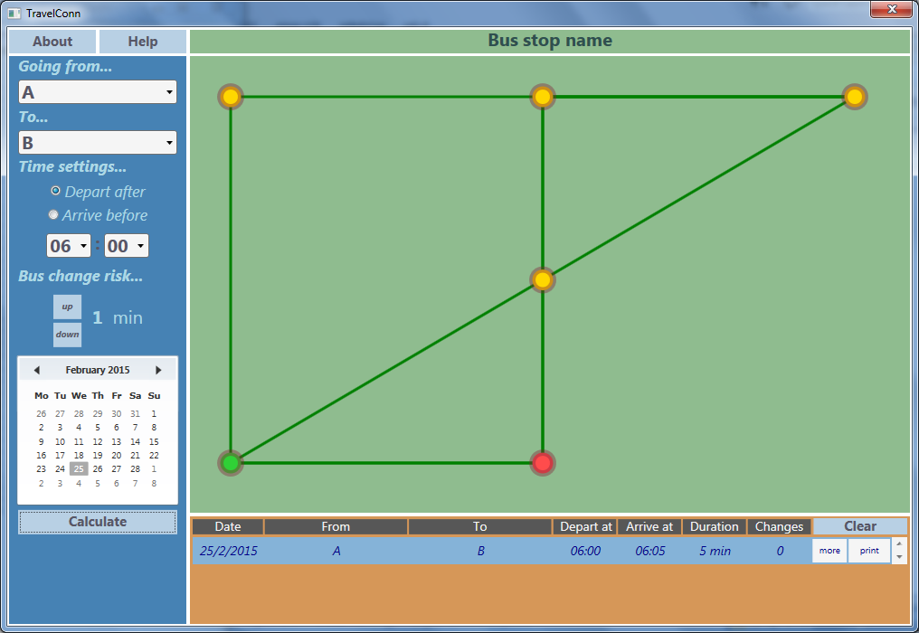 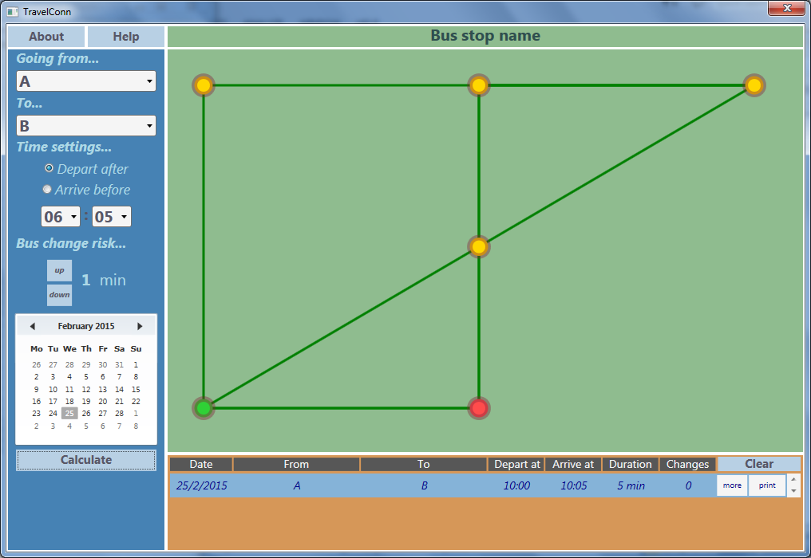

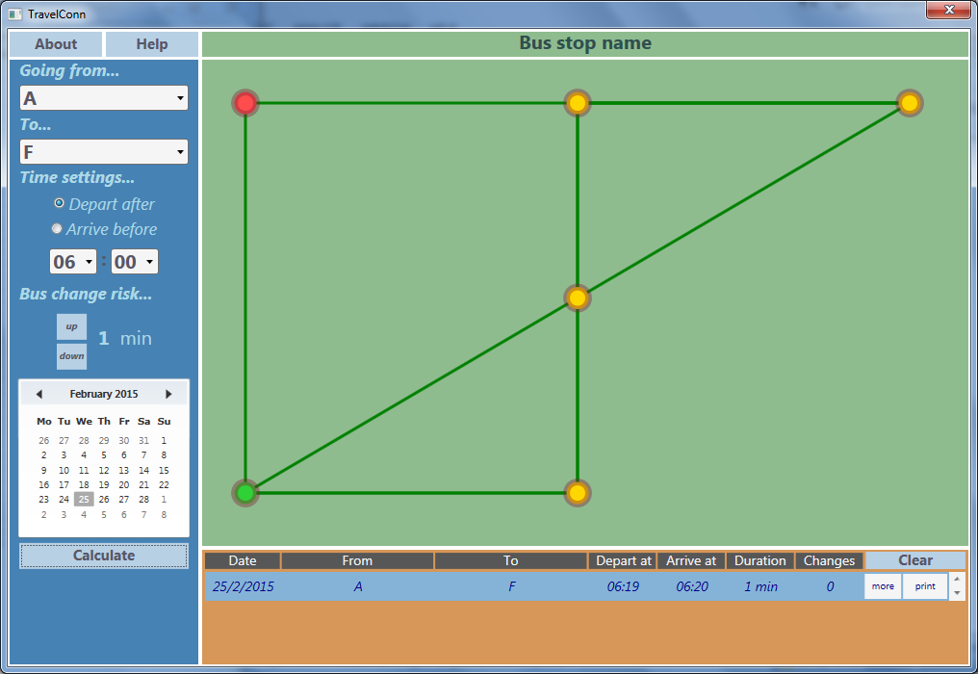 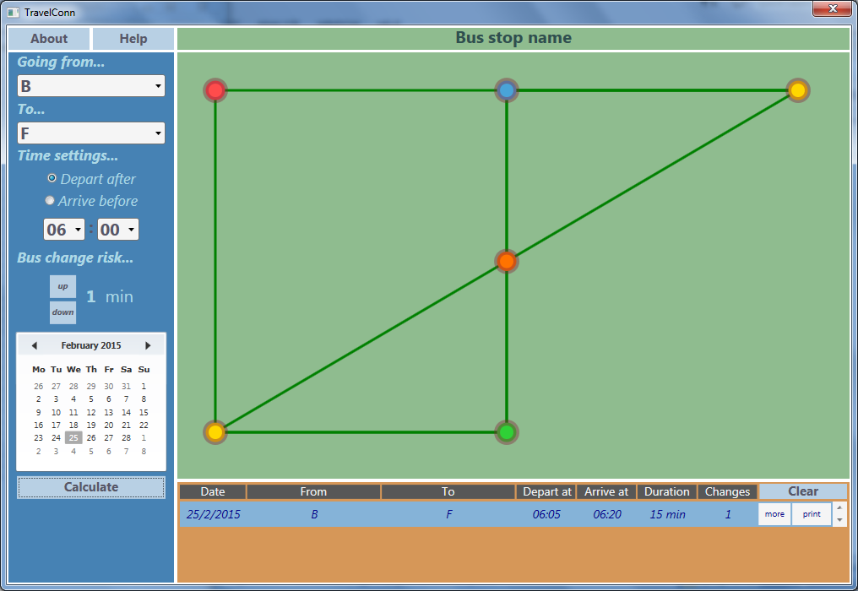

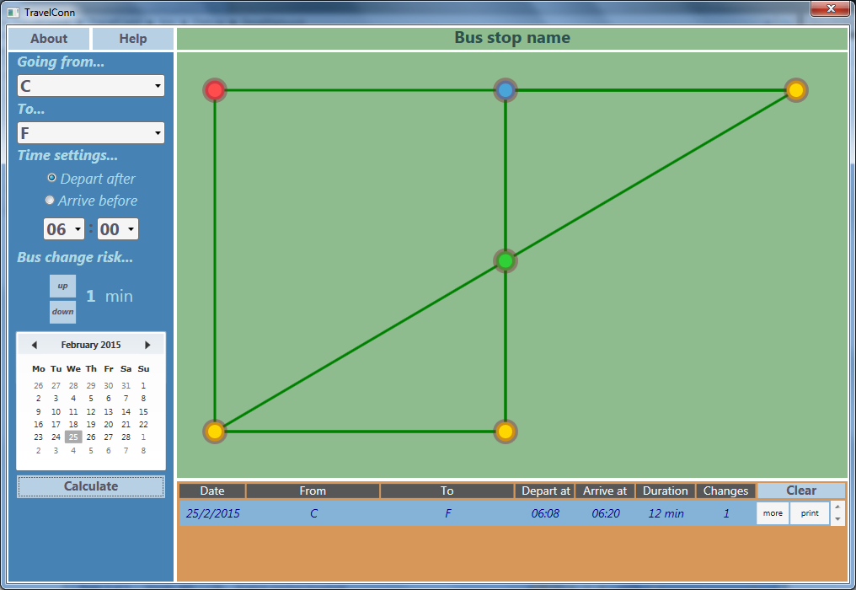

Testing the GUI:

Default values: 